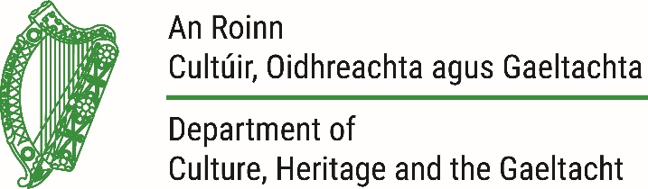

12 July 2019

Mr Seán Delmar
President, Irish Kennel Club

National Inventory of Intangible Cultural Heritage
Reference: EOI-1718-015 – Native Irish Pedigree Dog Breeds

Dear Seán,

I refer to your Expression of Interest submitted to the National Inventory of Intangible Cultural Heritage of Ireland for Native Irish Pedigree Dog Breeds.

An independent Expert Advisory Committee, convened by the Department and comprised of experts from across the spectrum of cultural heritage, assessed Expressions of Interest based on three criteria:
- Whether the submitted element is intangible cultural heritage
- Whether there is adequate community support and engagement
- Whether the submitted element is passed from generation to generation
I am pleased to let you know that the Committee agreed that your submission met all three criteria for inscription and decided to recommend its inscription on the National Inventory. The Minister approved the inscription on Thursday 11 July 2019. On behalf of the Minister and the Committee, I would like to congratulate you on your inscription and to thank for you for engaging in this process.

The Minister will launch the National Inventory on Thursday 18 July at 12pm in the Waterways Ireland Visitor Centre, Grand Canal Quay, Dublin. An invitation to the launch is enclosed with this correspondence.
We look forward to meeting you then.
Yours sincerely,
Stephen Kenneally
National Inventory of Intangible Cultural Heritage
nationalich@chg.gov.ie

